**Definition: Develop a banner of Recent activity of our college or any festival.**

**Solution:**

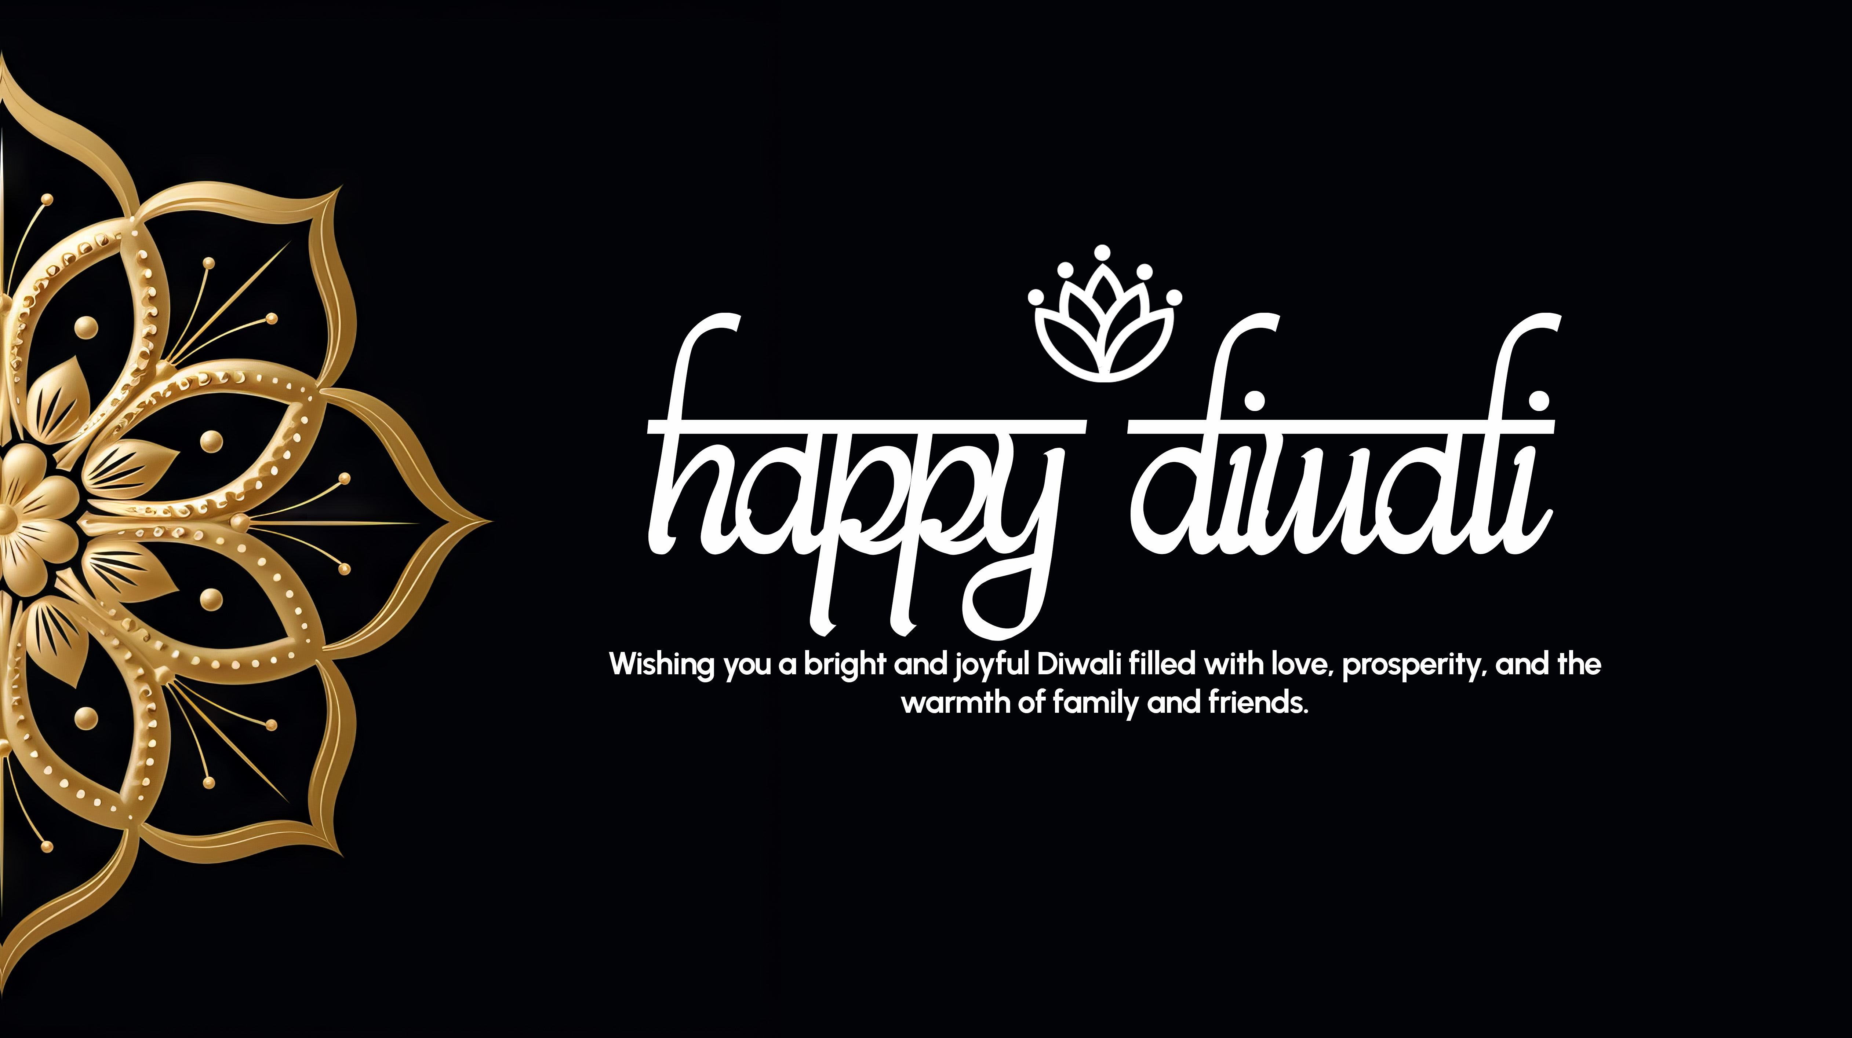

**Steps:**

* First Open photoshop.
* Then create the new document **File à New Photoshop Design.**
* Now add take one frame using the Frame tool and select a Desktop frame of width=”**4917px**” and height=”**2758px**” on your canvas.
* Add an image of golden flower on the left side of frame.
* Take Horizontal Type Tool and write “**Happy Diwali**” of font=”**bits Indian calligra**”, font size=”**900px**” and color=”**#FFFFFF**”.
* Now above the “**Happy Diwali**” text take an image of lotus flower.
* Also add another Horizontal Type Tool below the text and write “**Wishing you a bright and joyful Diwali filled with love, prosperity, and the warmth of family and friends.**” of font=”**Urbanist**”, font size=”**90px**” and color=” **#FFFFFF**”.
* Now, Go to **File à Save As** and save it with **.PSD/.JPEG/.PNG** format.